ZHOU Kevin
Student ID : A0197122H
NUS - IE5101 - Applied Forecasting Methods
Professor : Chen Nan
Project 2 : Forecasting Highway Car Volumes


Table of Contents
2.1 Regression on Time 2
2.2 Exponential Smoothing 2
2.3 Free form forecasting 2

2.1 Regression on Time

2.1.1 Regression on time

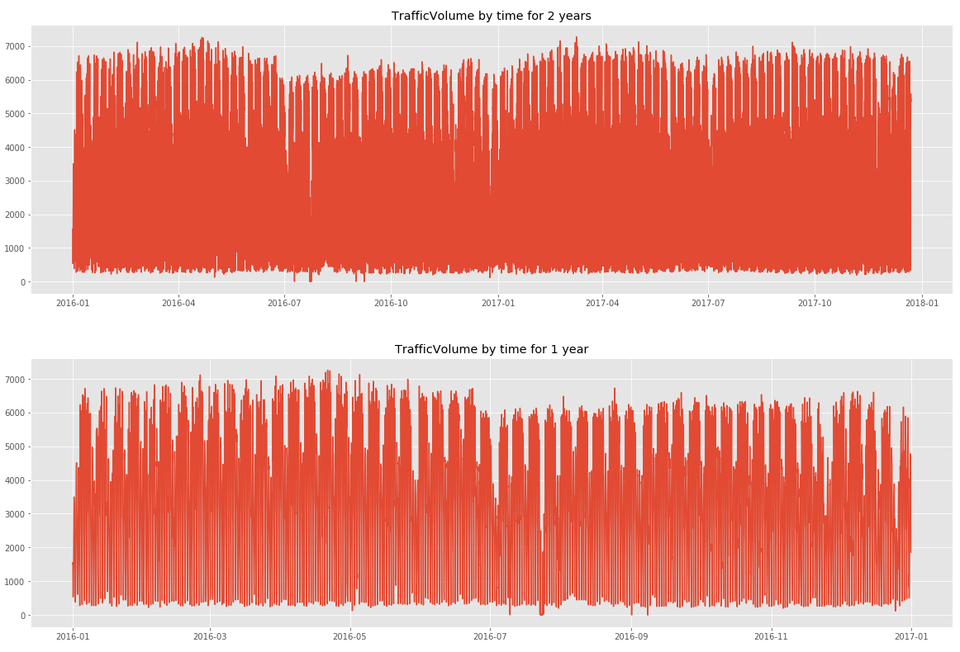
In this first part our regression will only consider the variables Time and TrafficVolume for prediction.

By plotting the Traffic volume, we notice some seasonality linked to the hour (peak around 7 am to 5 pm), to the day of the week (low traffic during the weekend) and and also to the month (plateau around April and minimum around July)
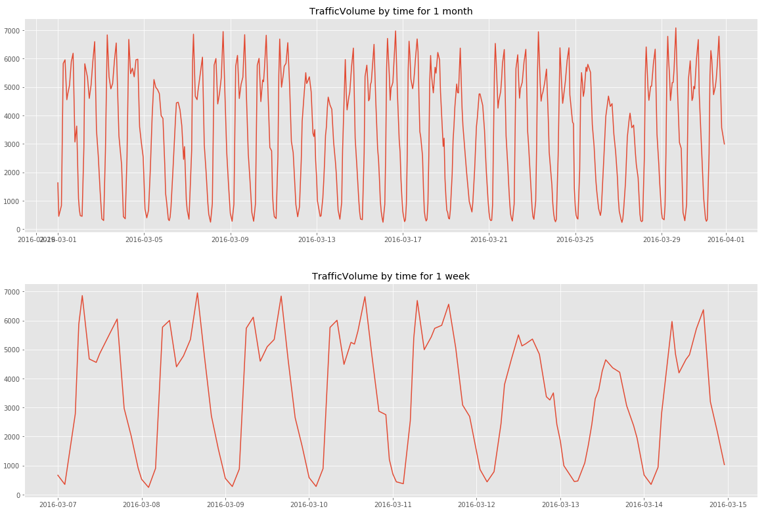
Hence to compute the linear regression, we will introduce dummy variables for the hour of the day, the day of the week and the month of the year and add the year to account for possible trend in time

This has yielded satisfactory results (below). All variables are taken are extremely relevant (p-values close to 0) except C(monthofyear)[T.12].
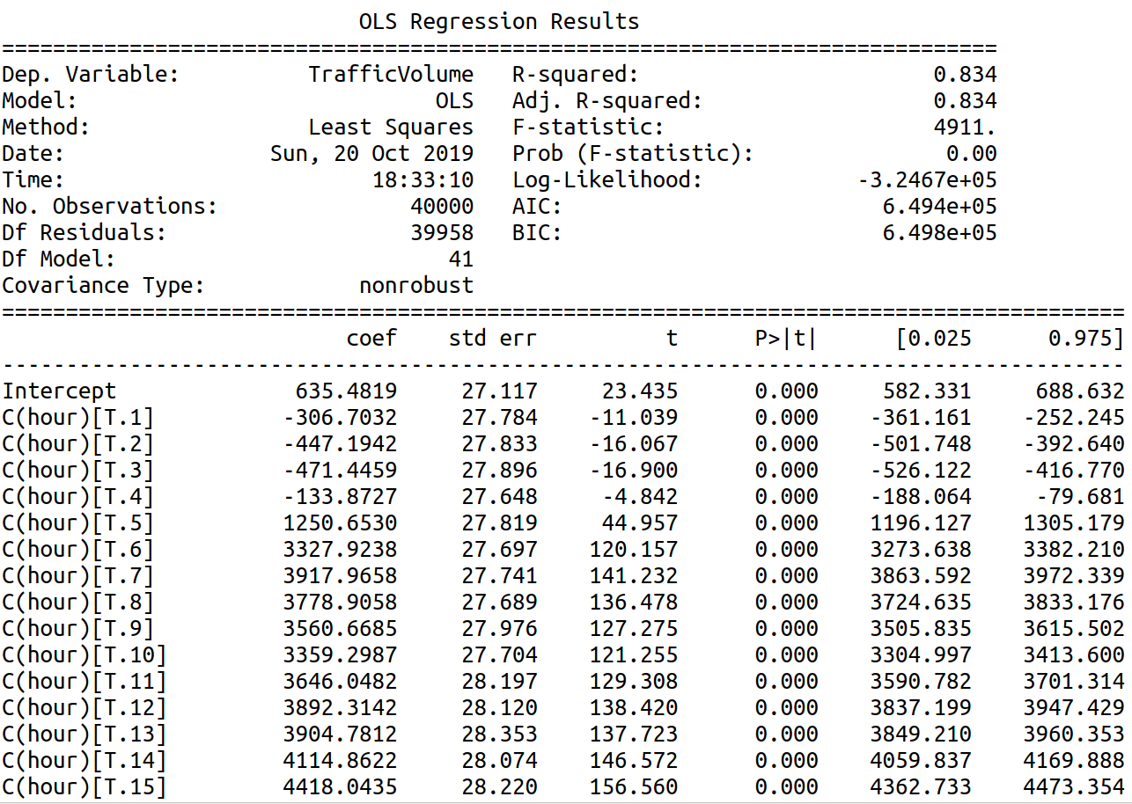
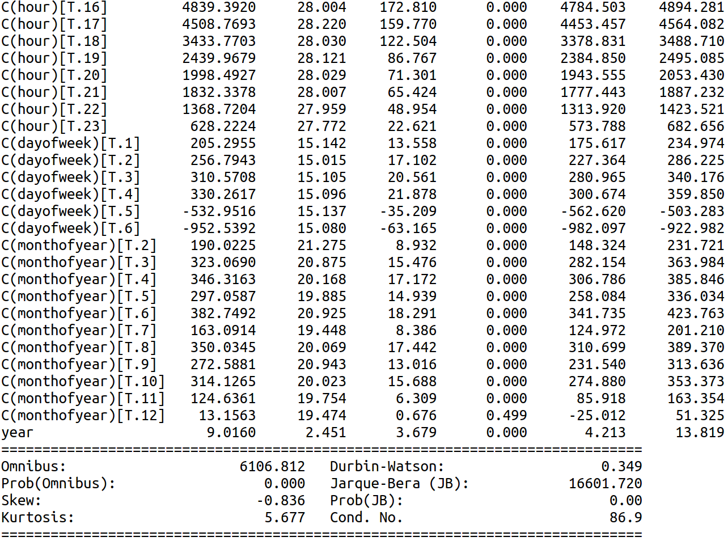

A full model regression with the list of possible features below have resulted in a slightly better R²-adjusted and smaller AIC. A stepwise forward selection regression to automatically select the best variables yielded similar results : better R²-adjusted and smaller AIC.
(‘hour', 'C(hour)', 'dayofweek', 'C(dayofweek)', 'dayofmonth', 'C(dayofmonth)', 'dayofyear', 'C(dayofyear)','C(weekofyear)', 'weekofyear', 'C(monthofyear)', 'monthofyear','year')

Both yielded slightly better results (1.1 point higher in R²-adjusted and 2000 lower in AIC) but have much complex models. For ease of interpretation, we will opt for the first regression model based on the AIC criteria.
Predicting future dates gives the right seasonal trend with however some values below 0.
Maybe some data cleaning necessary ? Look for values inferior to 0 :
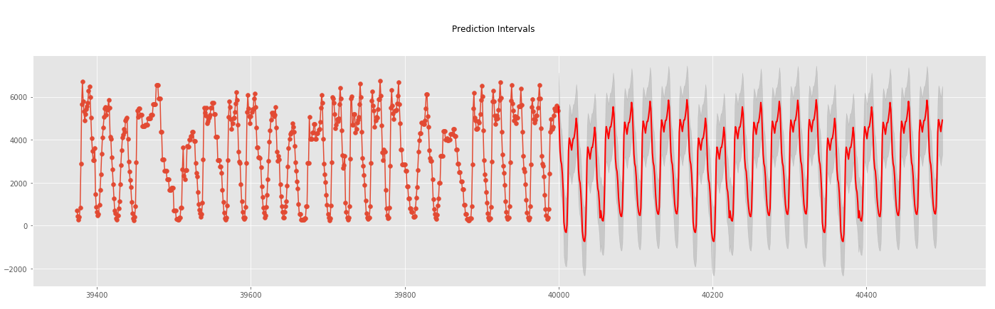
Diagnostic check
Residuals plot shows a non-normally distributed set of residuals
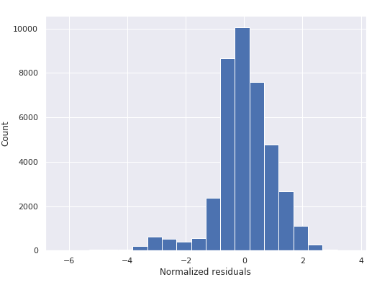
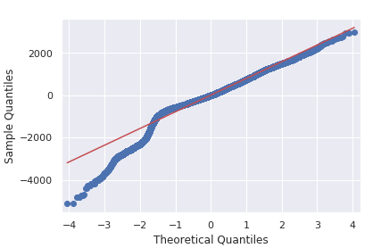
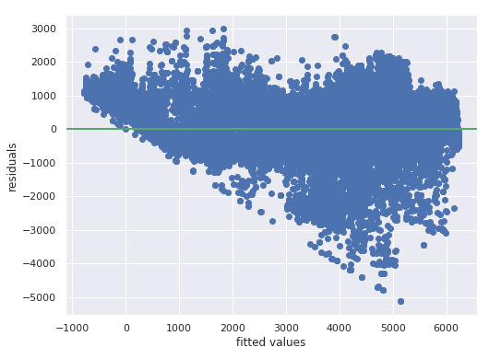

Model interpretation
To ease the interpretation, we have standardized the year variable : Year= Year -2012

2.2 Exponential Smoothing
In this task, you can apply appropriate exponential smoothing to make forecasting. Please explore
and verify your choice of model, and elaborate potential pros and cons of the model.

2.2.1 Exponential smoothing
We will apply a simple exponential smoothing based on the assumption that the observations follows a constant trend modal :
Y(t) = β +ε(t) with β the constant term and ε(t) the random residual term
We will calculate the optimal alpha given the SSE = sum([Y(i)-L(i-1)]²).
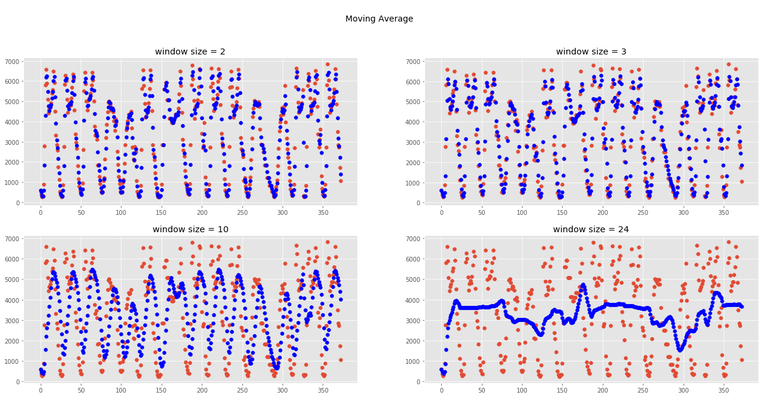
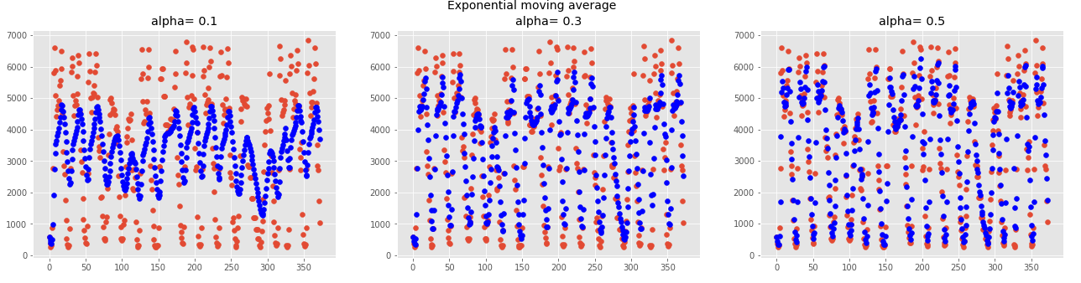
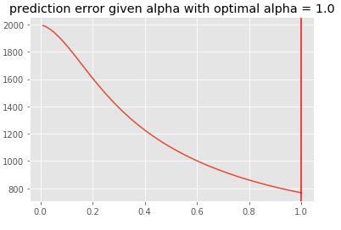
This resulted in an optimal alpha of 1.0 ie the optimal prediction is L(n) = Y(n). We may need to review our assumptions.

2.2.2 Verification of model
The exponential smoothing is based on a constant trend modal assumption.
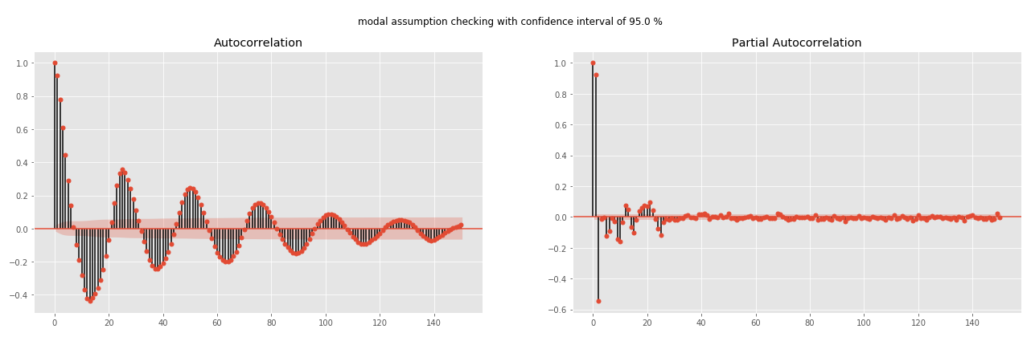
By plotting the autocorrelation plot, we do notice a sinusoidal autocorrelation function, which is a synonym for seasonality. As for the trend term, plotting the moving average by month and by year shows a relatively constant mean and thus can assume in first instance that the trend is constant
We can apply the Holt-Winters methods with a seasonal trend trend corrected smoothing and neglecting the linear trend term.
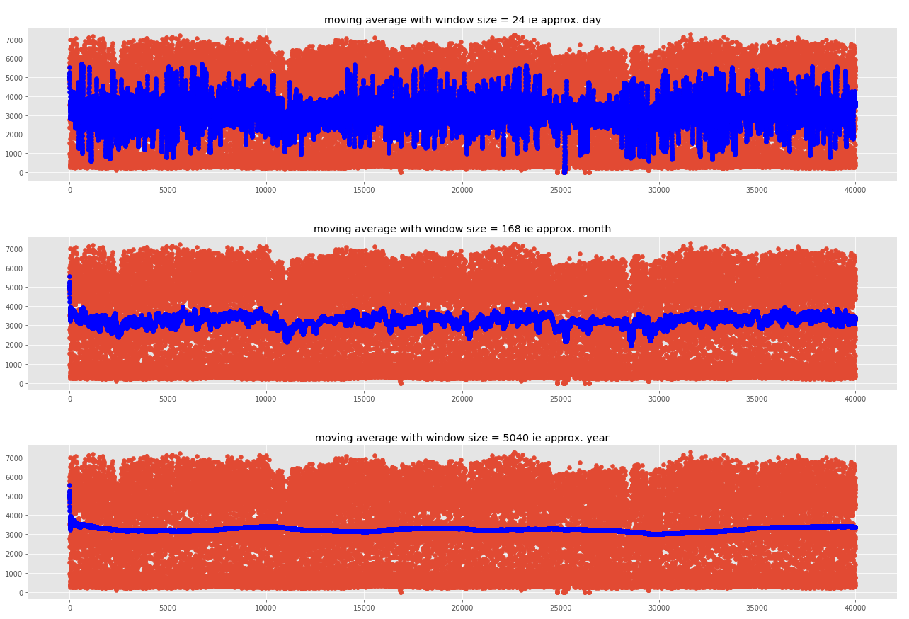

2.2.3 Upsides and downsides of the modal

2.3 Free form forecasting

We will apply the Box Jenkins methodologies (or ARIMA) to forecast the traffic volumes.
This methodology assumes stationary data i.e. mean, variance and autocorrelation are constant over time. Thus, we need to remove the seasonal term to have a stationary series. Then we will opt for an ARIMA modals to predict future values.

Seasonal ARMA model: y _{t} ∼ SARIMA(p, d, q) × (L, P, D, Q)
• L: the period of the seasonal effect
• P : the order of AR part at seasonal level
• Q: the order of MA part at seasonal level
• D: the order of differencing at seasonal level
-At non seasonal level :
First regular differencing : z _{t} = y _{t} − y _{t−1}
-At seasonal level :
First seasonal differencing: z _{t} = y _{t} − y _{t−L} with L = 24 (we need to be cautious though, the data is not completely clean as we do not have data for all hours and some hours have more than data)
-Combined :
First regular and seasonal differencing: z _{t} = y _{t} − y _{t-1} − ( y _{t-L} − y _{t-L-1} )

0- Test for stationarity : successful

Autocorrelation plot : 3 spikes for the PACF, we can try a AR(3) modal
autoregressive forecasting models are essentially linear regression models that utilize the lag(s) of the series itself as predictors.
We know that linear regression works best if the predictors (X variables) are not correlated against each other. So, stationarizing the series solves this problem since it removes any persistent autocorrelation, thereby making the predictors(lags of the series) in the forecasting models nearly independent.

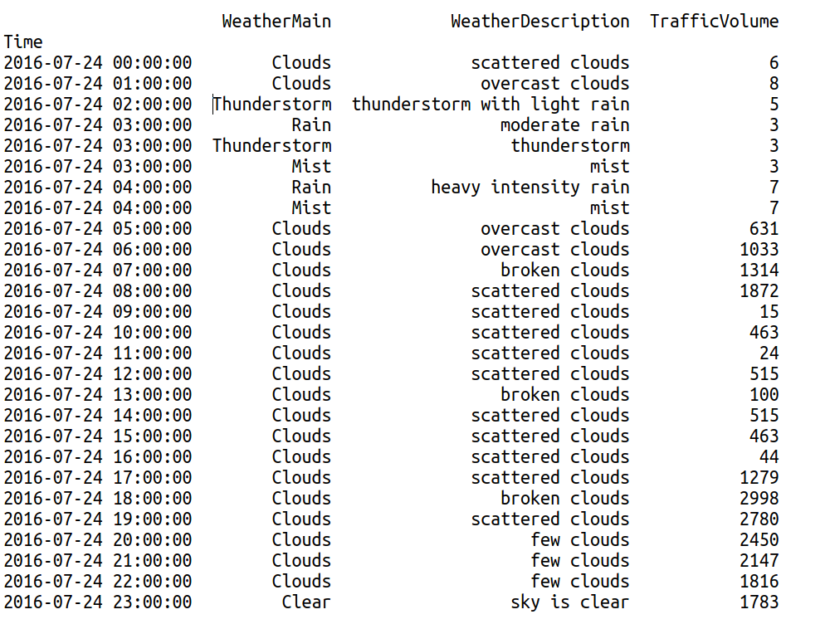
1-deseasonalize a time series needed if that series is stationary ? Is a seasonal series stationary ?
- 1. Take a moving average with length as the seasonal window. This will smoothen in series in the process.

- 2. Seasonal difference the series (subtract the value of previous season from the current value)

- 3. Divide the series by the seasonal index obtained from STL decomposition

